Noise pollution monitoring using IOT

Prepared by,

Mohammed Mudassir D

III year ECE

Dhaanish Ahmed College of engineering

# *Introduction to noise pollution:*

Noise pollution, often referred to as sound pollution, is the presence of unwanted or harmful noise in the environment. It is primarily generated by human activities, including industrial processes, transportation, and urban development. Noise pollution can have severe consequences for human health, leading to stress, sleep disturbances, hearing impairments, and cardiovascular problems. It also impacts wildlife, disrupting ecosystems and communication among species.

***Noise pollution Monitoring:***

Noise pollution monitoring is a critical component of environmental management and public health. This practice involves the systematic collection, analysis, and interpretation of data related to noise levels in various environments. As noise pollution continues to grow as an urban and industrial concern, monitoring its effects and sources becomes increasingly important. In this comprehensive exploration, we delve into the significance of noise pollution monitoring, the technologies and methodologies employed, and the broader implications for humaon health and the environment.

***Significance of Monitoring:***Monitoring noise pollution is essential to understand its prevalence, intensity, and distribution. It provides the foundation for implementing effective noise control measures, ensuring compliance with noise regulations, and enhancing the overall quality of life in urban and industrial areas.

***Traditional vs. Modern Approaches:*** Traditional noise monitoring methods involve periodic manual measurements using handheld devices. However, modern monitoring embraces advanced technologies, particularly the Internet of Things (IoT), to enable real-time data collection and analysis. IoT-based systems are capable of continuous data capture, providing a more holistic view of noise pollution.

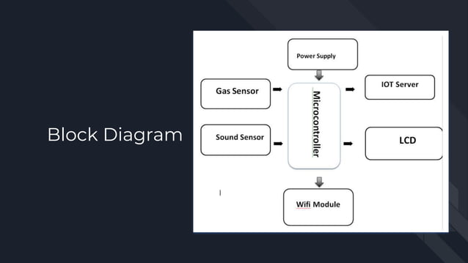

***Components of a Noise Pollution Monitoring System:***

1.Sensors: Specialized microphones, acoustic sensors, or sound level meters designed to capture sound data accurately.

2.Data Communication: Utilizes various communication protocols, including Wi-Fi, LoRa, and cellular networks, to transmit data.

3.Data Processing and Storage: Centralized servers or cloud platforms store and analyze the collected data.

4.User Interface: Interactive dashboards and visualization tools offer real-time insights into noise levels.

***Sensor Technology:*** The choice of sensor technology plays a pivotal role in the accuracy and reliability of noise data. High-precision microphones and sensors are commonly used. Proper sensor placement is critical to ensure representative measurements.

***Data Collection and Transmission:*** Noise data is continually collected by sensors and transmitted in real-time to central servers or cloud platforms. This instantaneous data flow enables prompt analysis and response.

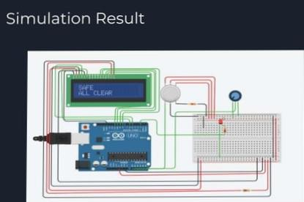

***Data Processing and Analysis:*** Collected data undergoes processing and analysis through algorithms designed to calculate noise levels and identify patterns. Advanced analysis techniques can reveal insights into noise pollution sources and trends.

***Visualization and User Interface:*** User-friendly interfaces provide stakeholders with graphical representations of noise data. Customization options allow users to tailor displays to their specific needs and preferences.

***Applications:*** IoT-based noise pollution monitoring systems find application in diverse fields, including urban planning, transportation management, industrial noise control, and public health. They empower decision-makers with data-driven insights for informed actions.

***Benefits and Advantages:*** These systems offer numerous benefits, including real-time access to noise data, remote monitoring capabilities, data trends and insights, and enhanced environmental and health management.

***Challenges and Solutions:*** Challenges in noise monitoring may encompass sensor power consumption and maintenance. Solutions involve optimizing power management and implementing regular sensor calibration.

***Future Trends:*** Future trends in noise pollution monitoring include the integration of artificial intelligence for advanced analytics and the incorporation of IoT into broader smart city initiatives.

In conclusion, noise pollution monitoring, particularly when facilitated by IoT technology, serves as a vital tool for addressing the pressing concerns associated with noise pollution. By providing stakeholders with timely and comprehensive data, it empowers them to enact measures that mitigate noise pollution’s adverse effects on human health and the environment while striving for sustainable and quieter urban environments.